Stage 5 – "You oughta see me drive."
COURSE DESIGNER: Rocky Perillo
SCORING: Comstock 31 rounds.
TARGETS: 14 cardboard targets, 3 Steel Targets
SCORED HITS: 2 Best hits per carboard will be scored.

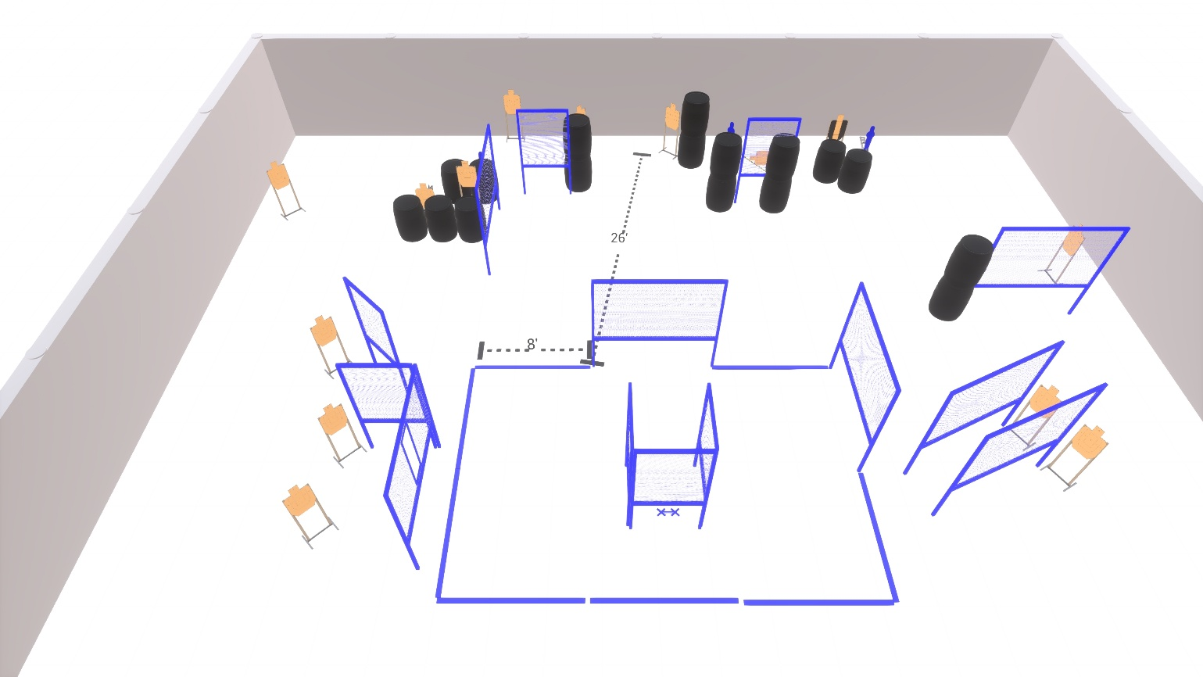

Written Stage Briefing:

Stage 5 – "You oughta see me drive." - is a 31 round, 155 point, Comstock Course. There are 14 cardboard targets and 3 steel targets.

Starting with both feet on XX’s facing generally down range.
Handgun is unloaded and holstered. Left hand touching left mark and right hand touching right mark.
PCC unloaded held in strong hand, stock touching belt, muzzle pointing down range with support hand touching support side mark.

On the audible start signal, engage targets from within the shooting area.

USPSA / NROI Range Commands:
- Make Ready
- Are you ready?
- Standby
- If finished, unload and show clear
- If clear, hammer down and holster (Handgun)
If clear, hammer down and flag (PCC)
If clear, cylinder closed and holster (Revolver)
- Range is clear

Setup Notes:
22 Single Wall Stands
3 Double Wall Stands
6 Full Walls
6 Half Walls
1 Port Walls
1 Swinger + cables
1 Bobber + cables
2 Activator Poppers
1 Mini Popper + base
14 Target stands / 28 target sticks
18+ Barrels



